**1. Introduction & Overview**

* **What the game is**
  + Golf 9 — a fast, competitive card game with a **3×3 grid per player**.
  + Supports **pass-and-play** (single device), **online real-time multiplayer and solo play vs AI**.
  + **Objective:** Lowest total score across **5 or 9 rounds**.

**2. Core Gameplay & Rules**

* **Deck Setup**
  + Uses 2× standard 52-card decks (supports 2–4 players).
  + Auto-reshuffle when draw pile empties (top discard remains).
* **Player Grid**
  + Each player has 9 face-down cards in a **3×3 grid**.
  + **Dynamic Grid Scaling:**
    - Grids shrink proportionally as player count increases to avoid any overlap.
    - Ensures grids and footer and header containers are scaled dynamically to fit on all device sizes using scaling best practices.
* **Card Values**
  + A = 1
  + 2–4, 6–10 = face value
  + 5 = −5
  + J/Q = 10
  + K = 0
* **Special Rule — 3 of a Kind**
  + Any 3 of a kind in a column zeros out that column, discards the cards in that column, and grants an **immediate extra turn**. During the extra turn, they must draw only from the draw pile to prevent drawing the discarded column cards from the discard pile.

**3. Standard Turn Flow**

* **Deal Phase**
  + Deal 9 cards face-down to each player.
  + Draw pile in center; 1 card flipped to start discard pile to the right of the draw pile.
* **Peek Phase**
  + Each player flips 2 cards face-up (everyone does this at the same time, unless its pass and play mode.
  + For Online Mode ONLY If player is idle after 15s → auto-play reveals randomly.
    - A circular progress ring animates around the player’s avatar:
      * Starts at green and gradually fills clockwise.
        + As time runs out, the ring shifts from green → yellow → red, giving a clear visual countdown.
    - When the circle completes, autoplay triggers, and 2 cards flip face up at random.
* **Turn Phase (Clockwise)**
  + Draw a card (from draw or discard pile).
    - If drawn from the draw pile, that card is highlighted in a blue outline, and flipped upright on top of the draw pile to visually indicate it is the active selection.
  + Choose a grid slot → Flip & Decide:
    - Keep Drawn (replace slot).
      * Include a visual transition to allow viewing players to process more clearly which card was replaced. (instead of doing it instantly)
    - Keep Revealed (discard drawn card).
      * Include a visual transition to allow viewing players to process more clearly which card was replaced. (instead of doing it instantly)
    - If the chosen grid slot is an already revealed card, replace that card and discard it.
      * Include a visual transition to allow viewing players to process more clearly which card was replaced. (instead of doing it instantly)
  + Rule applies: 3 of a Kind in a Column = 0 + extra turn (see special rule – 3 of a kind).
* **Idle Timer (**Online Mode ONLY**)**
  + Each player has 25 seconds to act on their turn.
    - A circular progress ring animates around the player’s avatar:
      * Starts at green and gradually fills clockwise.
        + As time runs out, the ring shifts from green → yellow → red, giving a clear visual countdown.
  + When the circle completes, autoplay triggers, still including visual card selection and replacement visual transitions for awareness.
* **Idle → Autoplay** 
  + 1 missed turn → AI plays for that turn.
  + 2 missed turns → AI fully takes control of following turns for that player until they return by performing an action.
    - Player marked as **Idle: Autoplay**.
    - AI plays immediately on each turn (no 35s wait).
      * Include a visual transition to allow viewing players to process more clearly which card was replaced. (instead of doing it instantly)
    - Player can reclaim control with any action.
* **AI Autoplay Logic**
  + Chooses discard pile first if low-value (Ace, 2–4, 5, King).
  + Otherwise risks drawing from pile.
  + AI plays blind to hidden cards—keeps human-like randomness.
  + As other players get closer to flipping over their last card for that round, prioritize flipping over un-flipped cards.
* **Visual Autoplay Cues**
  + 4-second delay to simulate human play.
  + Highlights drawn/discarded card + chosen grid slot.
  + Helps players follow AI reasoning in real time.
* **Round Closing**
  + When any player has all 9 cards revealed, all other players get one final turn.
  + Column match still applies.
  + Round ends, scores tallied.
* **Game End**
  + After 5 or 9 rounds → final results viewing (rankings, totals, crown on winner, exp earned, currency won/lost as applicable for the mode.).
  + Present Options: Play Again or Back to Lobby.

**4. User Interface & Experience (UX)**

* **Mode Selection:**
  + Modes: Pass-and-Play, Solo vs AI, Online Multiplayer (Room Code / Quick Play).
    - “How to Play” button.
    - See Visual #3 below for design concept.
* **Pre-Game Lobby**
  + **Select:**
    - Player Configurations: 2, 3, or 4 players.
    - Rounds: 5 or 9.
    - If Online mode: Create Room with Code, Join with Code, or quick play.
* **In-Game UI**
  + Player’s 3×3 grid at bottom; opponents compacted above.
    - See In-Game UI Grid Layouts below #6, #7 and #8 for each player count selection.
  + Discard + Draw piles always visible in-between player grid and opponent grid(s).
  + Held Card UX: drawn card shown on top of draw pile before decision.
* **Visual Enhancements**
  + Highlights:
    - Special Rule - 3 of a Kind → green outline around cards.
      * 0’s the card value and display.
    - Active selection → blue outline.
  + Card design: sleek, true-to-life deck.
  + Turn helpers: avatar & card highlights.
  + **Idle Mode Indicator:**
    - Small “Idle: Autoplay” label when AI controls.
    - Disappears instantly when player returns.
* **Progression & Engagement**
  + Live score tracking throughout the round(s).
    - During current round, and between total rounds played.
  + XP, level-ups, rewards (trophies, deck backs, currency).

**5. Additional Game Rules & Quality of Life**

* Auto-reshuffle discard pile into draw when needed (top discard remains).
* Lightweight flip/slide animations.
* Tap sound effects.
* **Improved Idle Auto-Play System:**
  + Fair, human-like AI decisions.
  + Smooth autoplay flow with real-time cues.

**6. Technology & Development Integrity**

* **Platforms:** Built for **Google Play** + **iOS App Store**.
* **Game Integrity:**
  + No hidden-info leaks.
  + Column-match & closing logic enforced consistently.
  + Discard-to-draw reshuffle keeps top discard intact.
  + Only 2 cards can be flipped per player during peek phase, drawn and discard piles are locked during peek phase, (enforced).
  + Only 1 card can be un-flipped per turn, unless the make the special 3 of a kind rule (enforced)
* **Scalable UI:**
  + Board scales with 2, 3, or 4 players.
  + All UI Items such as buttons, grids, discard, draw pile, avatars and anything else never overlap – dynamic scaling best practices used to be flexible for varying displays/devices.
  + Compact opponent accordingly to make opponent grids always visible without the need to scroll.

|  |  |
| --- | --- |
| 1. Login Screen Concept   Golf 9  The Card Game  Hi, | 1. Display for new users upon login, as well as for when they click “How to Play” |
|  | Grouped object  **How to Play** |

**Visual Layout Screen concepts for the App**

|  |  |
| --- | --- |
| 1. Main Lobby (Mode Select) + Settings Hamburger Menu and Avatar logo for profile settings. EXP, Curreny. | 1. Hamburger Settings Layout Concept |
| Grouped object  **How to Play** | |  | | --- | | Sound | | Vibrate | | Logout |   Grouped object  **How to Play** |

|  |
| --- |
| 1. Profile Settings Layout Concept |
| Grouped object  **How to Play** |

1. 2 Player 3x3 Grid Layout:
   1. 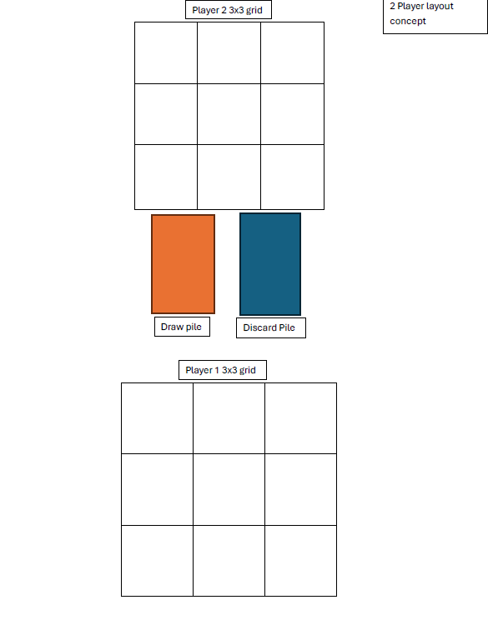
2. 3 Player Gird Layout:
   1. 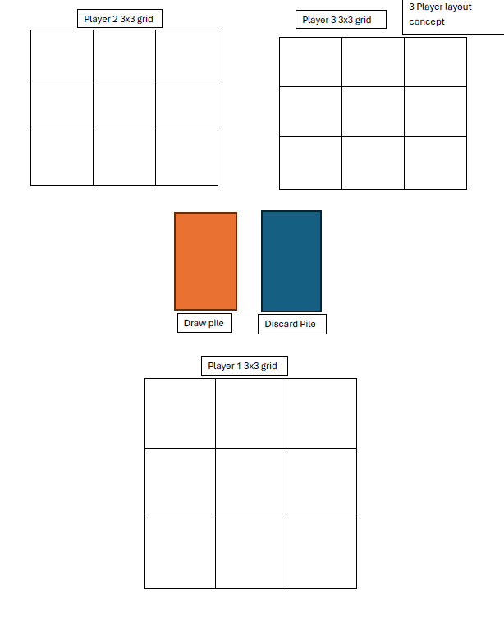
3. 4 Player Grid Layout:
   1. 